Sunrise Supermarket — PL/SQL Assignment One
21. Author
Student Name: MUSANA Jean Bosco
Student ID: 27133
Group: C
Course: PL/SQL / Database
DBMS: Oracle Database

1. Introduction
Sunrise Supermarket is a retail business that sells different products to customers. Customers can place orders, and each order can contain one or more products.
The management of Sunrise Supermarket wants to analyze its customers, products, orders, and sales. The purpose of this assignment is to design and populate a relational database and use SQL queries to obtain useful business information.
The assignment demonstrates the use of:
- INNER JOIN
- LEFT JOIN
- Common Table Expressions (CTEs)
- Window Functions
- Aggregate Functions
- RANK()
- ROW_NUMBER()
- LAG()
- Running totals
- Date calculations
2. Business Scenario
Sunrise Supermarket sells products such as milk, bread, rice, sugar, cooking oil, yogurt, biscuits, juice, tea, and flour.
Customers place orders for these products. Each order belongs to one customer, while each order can contain several order items. Each order item identifies a product and the quantity purchased.
The supermarket wants to use its database to answer questions such as:
- Which customers have placed orders?
- What products are included in each order?
- Which customers have not placed any orders?
- Which customers spend more than the average?
- Who are the highest-spending customers?
- How many orders has each customer placed?
- How does revenue accumulate over time?
- How many days are between a customer's orders?
3. Project Objectives
The main objectives of this project are to:
- Create a relational database for Sunrise Supermarket.
- Store customer information.
- Store product information.
- Store customer orders.
- Store products and quantities contained in each order.
- Populate the database with realistic sample data.
- Use JOIN operations to combine information from different tables.
- Use a CTE to identify customers spending above the average.
- Use window functions to analyze customer spending and order patterns.
- Generate useful information that can support supermarket management decisions.
4. Database Management System
This project was implemented using:
Oracle Database
Oracle SQL Developer was used to create the tables, insert data, and execute the SQL queries.
5. Database Design
The database contains four main tables:
5.1 Customers
The customers table stores information about customers.
Column | Description
customer_id | Unique ID of the customer
customer_name | Name of the customer
email | Customer email address
city | Customer's city
5.2 Products
The products table stores information about products sold by the supermarket.
Column | Description
product_id | Unique ID of the product
product_name | Name of the product
category | Product category
price | Product selling price
5.3 Orders
The orders table stores customer orders.
Column | Description
order_id | Unique ID of the order
customer_id | ID of the customer who placed the order
order_date | Date when the order was placed
5.4 Order Items
The order_items table stores the products included in each order.
Column | Description
order_item_id | Unique ID of the order item
order_id | ID of the related order
product_id | ID of the purchased product
quantity | Number of units purchased
6. Relationships Between Tables
The tables are connected using primary keys and foreign keys.
Customers → Orders
One customer can place many orders.
Relationship:
Customers 1 : N Orders
The customer_id in the orders table references customer_id in the customers table.
Orders → Order Items
One order can contain many order items.
Relationship:
Orders 1 : N Order_Items
The order_id in the order_items table references order_id in the orders table.
Products → Order Items
One product can appear in many order items.
Relationship:
Products 1 : N Order_Items
The product_id in the order_items table references product_id in the products table.
Overall Relationship
CUSTOMERS
|
| 1
|
| N
ORDERS
|
| 1
|
| N
ORDER_ITEMS
|
| N
|
| 1
PRODUCTS
The order_items table connects orders and products.
7. Database Population
The database was populated with:
- 6 customers
- 10 products
- 18 orders
- 35 order items
- Products from multiple categories
- Orders from multiple dates in September 2026
The customers include:
- Jean Bosco
- Alice Mukamana
- Eric Niyonzima
- Diane Uwase
- Patrick Habimana
- Grace Ingabire
Grace Ingabire was intentionally included without an order so that the LEFT JOIN query could demonstrate how customers without orders are identified.
8. SQL Queries and Analysis
Query 1 — INNER JOIN Customers and Orders
SQL Query
SELECT
o.order_id,
c.customer_name,
c.city,
o.order_date
FROM orders o
INNER JOIN customers c
ON o.customer_id = c.customer_id
ORDER BY o.order_date;
Explanation
This query uses an INNER JOIN to combine the orders and customers tables.
The query displays:
- Order ID
- Customer name
- Customer city
- Order date
Only customers who have an order are returned.
Result
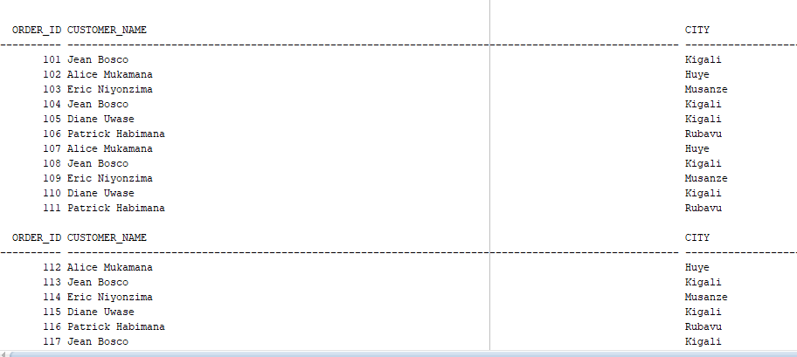
The query returned 18 rows, representing the 18 orders in the database.
Business Interpretation
This information allows Sunrise Supermarket to know which customer placed each order and when the order was placed.
It can help management analyze customer purchasing activity and order history.
Screenshot
Add the Oracle SQL Developer result screenshot here.
Screenshot: join1.png
9. Query 2 — INNER JOIN Order Items and Products
SQL Query
SELECT
oi.order_item_id,
oi.order_id,
p.product_name,
p.category,
p.price,
oi.quantity
FROM order_items oi
INNER JOIN products p
ON oi.product_id = p.product_id
ORDER BY oi.order_id;
Explanation
This query joins the order_items table with the products table.
It shows the products included in each order together with:
- Product name
- Product category
- Product price
- Quantity purchased
Result
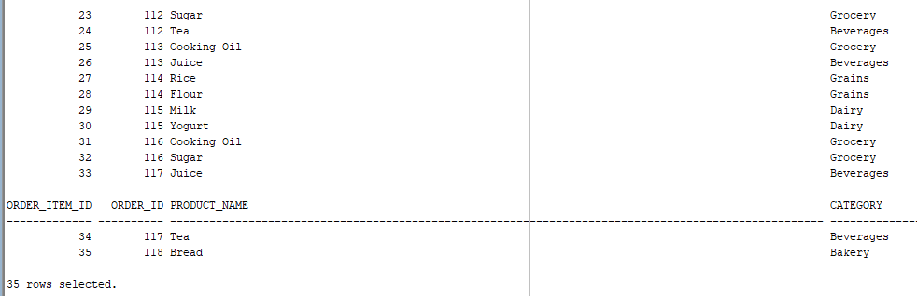
The query returned 35 rows, representing the 35 order items.
Business Interpretation
The supermarket can use this information to understand which products customers purchased and the quantities purchased.
This can support inventory management and sales analysis.
Screenshot
Screenshot: join2.png
10. Query 3 — LEFT JOIN Customers and Orders
SQL Query
SELECT
c.customer_id,
c.customer_name,
o.order_id,
o.order_date
FROM customers c
LEFT JOIN orders o
ON c.customer_id = o.customer_id
ORDER BY c.customer_id, o.order_date;
Explanation
This query uses a LEFT JOIN.
A LEFT JOIN returns all customers, even if they have never placed an order.
Customers who have orders display their order information. Customers without orders have NULL values for the order columns.
Result
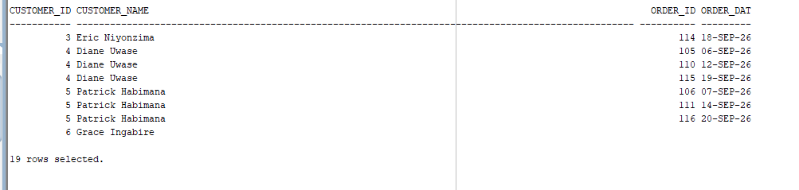
The query returned 19 rows.
Grace Ingabire appears without an order ID or order date because she has not placed any order.
Business Interpretation
This query helps management identify customers who are not currently purchasing from the supermarket.
The supermarket could use this information for customer engagement or promotional activities.
Screenshot
Screenshot: join3.png
11. Query 4 — CTE for Customers Above Average Spending
SQL Query
WITH customer_totals AS (
SELECT
c.customer_id,
c.customer_name,
SUM(oi.quantity * p.price) AS total_spend
FROM customers c
JOIN orders o
ON c.customer_id = o.customer_id
JOIN order_items oi
ON o.order_id = oi.order_id
JOIN products p
ON oi.product_id = p.product_id
GROUP BY c.customer_id, c.customer_name
)
SELECT
customer_id,
customer_name,
total_spend
FROM customer_totals
WHERE total_spend > (
SELECT AVG(total_spend)
FROM customer_totals
)
ORDER BY total_spend DESC;
Explanation
A Common Table Expression (CTE) is created using the WITH keyword.
The CTE calculates the total amount spent by each customer.
The second part of the query calculates the average customer spending and returns customers whose spending is greater than the average.
Result
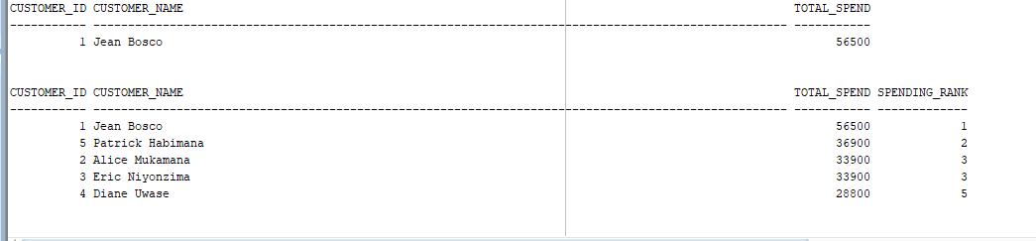
The query identified:
Jean Bosco — 56,500
as the customer whose total spending is above the average spending of customers who placed orders.
Business Interpretation
The supermarket can identify customers who contribute a relatively large amount of revenue.
This information can support customer retention and loyalty strategies.
Screenshot
Screenshot: cte.png
12. Query 5 — Ranking Customers by Total Spending
SQL Query
WITH customer_totals AS (
SELECT
c.customer_id,
c.customer_name,
SUM(oi.quantity * p.price) AS total_spend
FROM customers c
JOIN orders o
ON c.customer_id = o.customer_id
JOIN order_items oi
ON o.order_id = oi.order_id
JOIN products p
ON oi.product_id = p.product_id
GROUP BY c.customer_id, c.customer_name
)
SELECT
customer_id,
customer_name,
total_spend,
RANK() OVER (ORDER BY total_spend DESC) AS spending_rank
FROM customer_totals
ORDER BY spending_rank;
Explanation
The RANK() window function ranks customers according to their total spending.
The customer with the highest total spending receives rank 1.
Result
The spending amounts are:
Customer | Total Spending
Jean Bosco | 56,500
Patrick Habimana | 36,900
Alice Mukamana | 33,900
Eric Niyonzima | 33,900
Diane Uwase | 28,800
Alice Mukamana and Eric Niyonzima have the same total spending, so RANK() gives them the same rank.
Business Interpretation
Customer spending rankings allow management to compare customer purchasing levels and understand the distribution of revenue among customers.
Screenshot
Screenshot: window1.png
13. Query 6 — Number Each Customer's Orders
SQL Query
SELECT
o.customer_id,
c.customer_name,
o.order_id,
o.order_date,
ROW_NUMBER() OVER (
PARTITION BY o.customer_id
ORDER BY o.order_date
) AS order_number
FROM orders o
JOIN customers c
ON o.customer_id = c.customer_id
ORDER BY o.customer_id, o.order_date;
Explanation
The ROW_NUMBER() window function assigns a number to each order.
PARTITION BY customer_id means that the numbering starts again for each customer.
The orders are numbered according to their dates.
Example
For Jean Bosco:
Order ID | Date | Order Number
101 | 01-SEP-26 | 1
104 | 05-SEP-26 | 2
108 | 10-SEP-26 | 3
113 | 17-SEP-26 | 4
117 | 21-SEP-26 | 5
Business Interpretation
This allows the supermarket to understand the order sequence of each customer and measure repeat purchasing behavior.
Screenshot
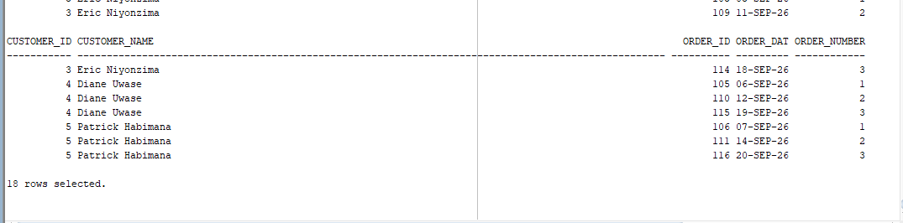
14. Query 7 — Running Total Revenue
SQL Query
WITH order_revenue AS (
SELECT
o.order_id,
o.order_date,
SUM(oi.quantity * p.price) AS order_revenue
FROM orders o
JOIN order_items oi
ON o.order_id = oi.order_id
JOIN products p
ON oi.product_id = p.product_id
GROUP BY o.order_id, o.order_date
)
SELECT
order_id,
order_date,
order_revenue,
SUM(order_revenue) OVER (
ORDER BY order_date, order_id
ROWS BETWEEN UNBOUNDED PRECEDING AND CURRENT ROW
) AS running_revenue
FROM order_revenue
ORDER BY order_date, order_id;
Explanation
This query first calculates the revenue generated by each order.
The window function then calculates a running total of revenue according to the order date.
The running total starts from the first order and continuously adds the revenue from subsequent orders.
Business Interpretation
A running revenue total helps management understand how sales accumulate over time.
It can be useful for monitoring sales performance and identifying periods of increasing or decreasing revenue.
Screenshot
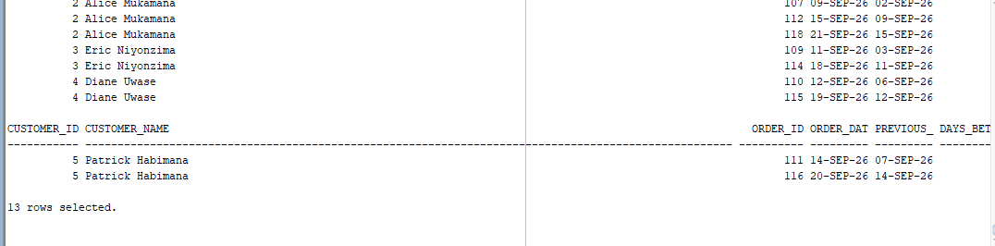
15. Query 8 — Days Between Customer Orders
SQL Query
WITH customer_orders AS (
SELECT
o.customer_id,
c.customer_name,
o.order_id,
o.order_date,
LAG(o.order_date) OVER (
PARTITION BY o.customer_id
ORDER BY o.order_date
) AS previous_order_date
FROM orders o
JOIN customers c
ON o.customer_id = c.customer_id
)
SELECT
customer_id,
customer_name,
order_id,
order_date,
previous_order_date,
order_date - previous_order_date AS days_between_orders
FROM customer_orders
WHERE previous_order_date IS NOT NULL
ORDER BY customer_id, order_date;
Explanation
The LAG() window function retrieves the previous order date for each customer.
Oracle allows two DATE values to be subtracted. The result represents the number of days between the two dates.
The first order of each customer is excluded because it does not have a previous order.
Example
For Jean Bosco:
Order ID | Current Date | Previous Date | Days Between
104 | 05-SEP-26 | 01-SEP-26 | 4
108 | 10-SEP-26 | 05-SEP-26 | 5
113 | 17-SEP-26 | 10-SEP-26 | 7
117 | 21-SEP-26 | 17-SEP-26 | 4
Business Interpretation
This information helps the supermarket understand how frequently customers return to make purchases.
It can support customer retention analysis and help management understand purchasing patterns.
Screenshot
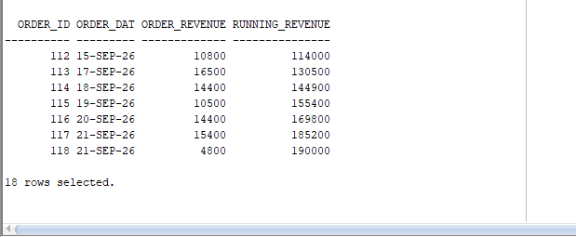
16. Summary of SQL Techniques Used
Query | SQL Technique | Purpose
Query 1 | INNER JOIN | Connect customers with orders
Query 2 | INNER JOIN | Connect order items with products
Query 3 | LEFT JOIN | Find all customers, including those without orders
Query 4 | CTE | Find customers above average spending
Query 5 | RANK() | Rank customers by spending
Query 6 | ROW_NUMBER() | Number orders for each customer
Query 7 | SUM() OVER | Calculate running revenue
Query 8 | LAG() | Find time between customer orders
17. Challenges and Solutions
Challenge 1 — Understanding JOIN Relationships
One challenge was understanding how the four tables are connected.
Solution
The relationships were identified using the primary keys and foreign keys:
- customer_id connects customers and orders.
- order_id connects orders and order items.
- product_id connects products and order items.
Challenge 2 — Understanding LEFT JOIN
It was necessary to make sure customers without orders were still displayed.
Solution
A LEFT JOIN was used between customers and orders. This allowed all customers to appear, including Grace Ingabire, who has no order.
Challenge 3 — Understanding Window Functions
Window functions such as RANK(), ROW_NUMBER(), and LAG() can be difficult to understand because they perform calculations across related rows without grouping them into a single row.
Solution
The functions were used with PARTITION BY and ORDER BY to control how the calculations were performed.
Challenge 4 — Calculating Revenue
Revenue needed to be calculated using both product price and quantity.
Solution
The following calculation was used:
quantity * price
The result was then aggregated using SUM().
18. How to Run the Project
Step 1 — Install Oracle Database
Make sure Oracle Database is installed and running.
Step 2 — Open Oracle SQL Developer
Connect to the Oracle database using the appropriate database user.
Step 3 — Create the Tables
Run the SQL statements contained in:
sql/tables.sql
Step 4 — Insert the Data
Run:
sql/data.sql
This populates the database with the customers, products, orders, and order items.
Step 5 — Run the Queries
Open:
sql/queries.sql
Run the queries to obtain the results.
Step 6 — Review the Results
The query results can be viewed in Oracle SQL Developer.
Screenshots of the results are stored in:
screenshots/
19. Project Structure
The project is organized as follows:
assignment_1_musana jean bosco-27133/
│
├── README.md
│
├── sql/
│ ├── tables.sql
│ ├── data.sql
│ └── queries.sql
│
└── screenshots/

20. Conclusion
The Sunrise Supermarket database demonstrates how SQL can be used to manage and analyze supermarket data.
The project used different SQL techniques, including JOINs, CTEs, aggregate functions, and window functions.
The queries provided information about customer orders, products purchased, customer spending, customer rankings, order sequences, revenue growth, and the time between customer purchases.
These results demonstrate how a relational database can provide useful information for business analysis and decision-making.

